CS 3365 – Software Engineering I

Prof. Michael Shin

Homework #1

Luis Rausseo – R11478074

**Hotel System**

Problem Statement

A hotel system manages information about rooms, reservations, customers, and customer billing. A customer can make reservations, change, or cancel reservations through the hotel website. When a customer makes reservations, he/she needs to check if a room the customer want to reserve is available. If a room is available, the customer enters his/her information to the system and receives a confirmation number from the web site.

A desk clerk checks in a customer with only a prior reservation, change the checkout date, and check out the customer. A room is assigned to the customer at check-in time and a customer billing record is created at that time. The customer billing record is updated every night at 12. When a customer checks out, the desk clerk prints the bill. A customer can pay by cash, check, or credit card when he/she checks out.

**1.** Develop the use case diagram showing actors and use cases for the hotel system.

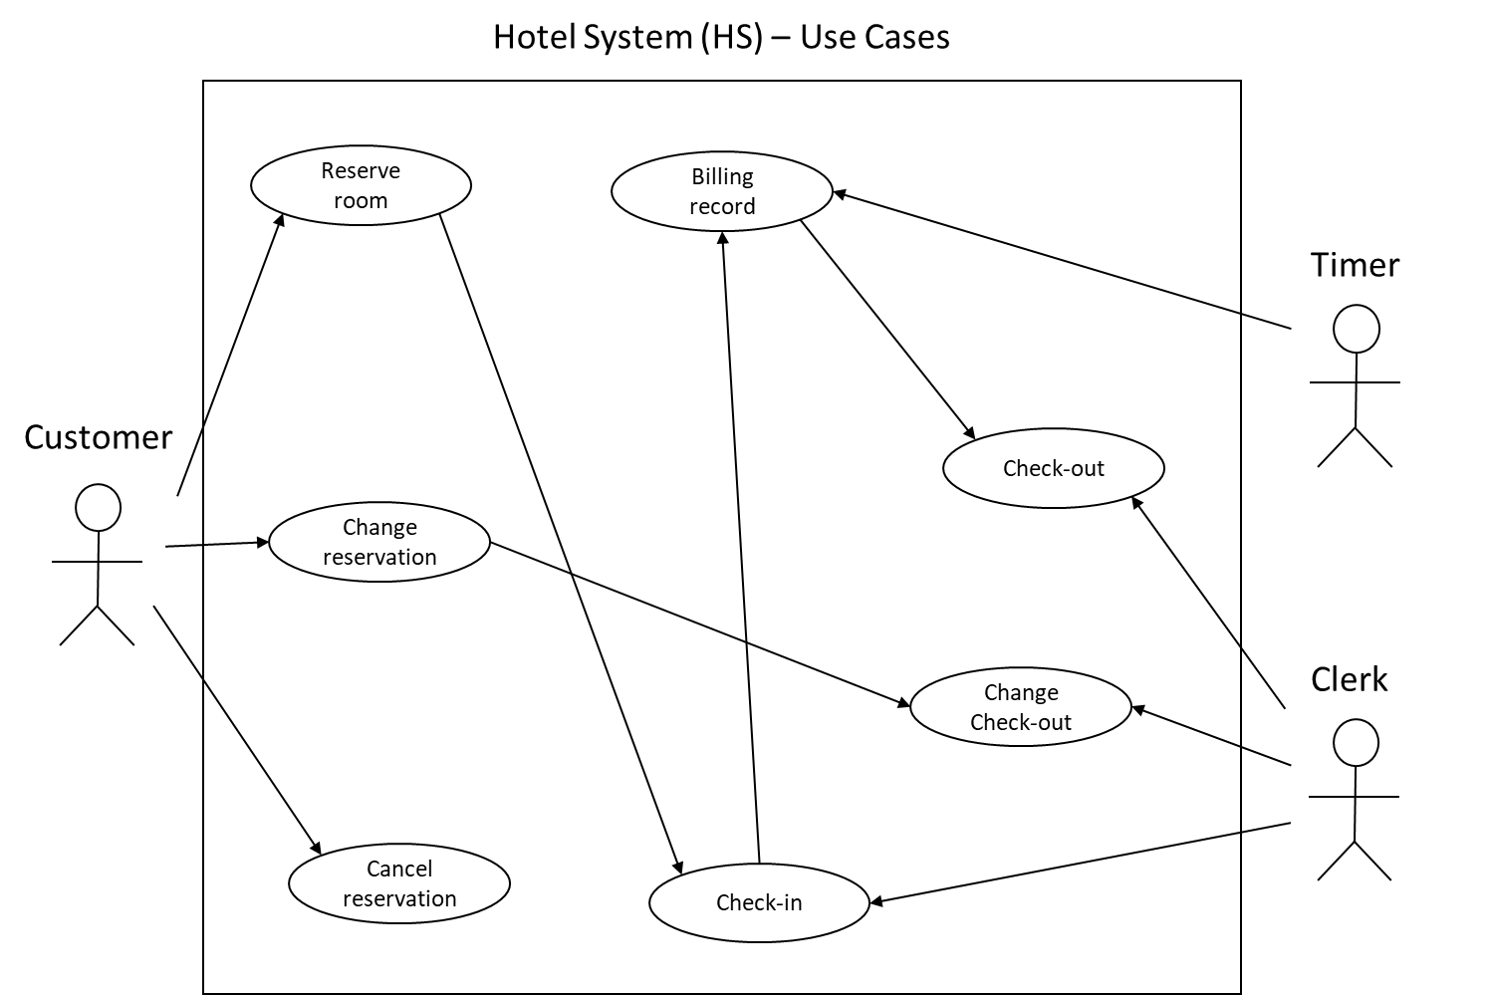

**2.** Describe Reserve Room use case using the template for use case description.

**Use Case:** *Reserve Room*

**Description:** The customer goes to the hotel’s website and proceed to reserve a room. The customer checks if there are rooms available in the date range desired. If they are, the customer enters the required personal information and receives a confirmation from the website.

**Actor:** Customer, Hotel System.

**Pre-Conditions**: None.

**Main Sequence:**

1. Customer clicks on “Reserve Room” button at hotel’s website and is redirected to the room reserving system.
2. Customer enters the type of room and date range desired.
3. System checks the rooms and dates and inform the customer is there is a room available.
4. Customer fills out form with all the required personal information and submits it.
5. System stores customer’s information and prints out the reservation’s confirmation number.

**Alternative Sequence:**

1. If there are no rooms available, the system prints an error message and ask the customer to change the room information. The customer can select other room type, change dates, or cancel the reservation process.

**Post-condition:** The customer has reserved a room in the hotel.